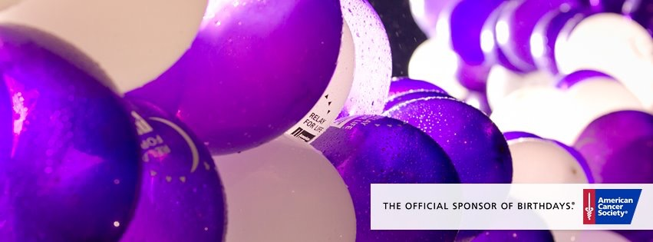
Join us!!
VENDOR FAIR
benefiting
Relay For Life of Lincoln

Saturday, December 5th
9:00am to 2:00pm
Lincoln High North Gymnasium
134 Old River Lincoln, RI 02865

Start your holiday shopping while giving back to the Lincoln community & supporting the annual Relay For Life of Lincoln!
There will be food and raffles with proceeds going directly to the fight against cancer! Featuring:
Ava Anderson Origami Owl Touch Stone Crystals Jamberry Nails Rondan & Fields Tastefully Simple Changing Leaf Pottery Thirty-One
and many more…

