** Thank you to all our sponsors:**

**Relay For Life of   
Vinings Buckhead**

**May 29, 2015**

**relayforlife.org/viningsbuckheadga**

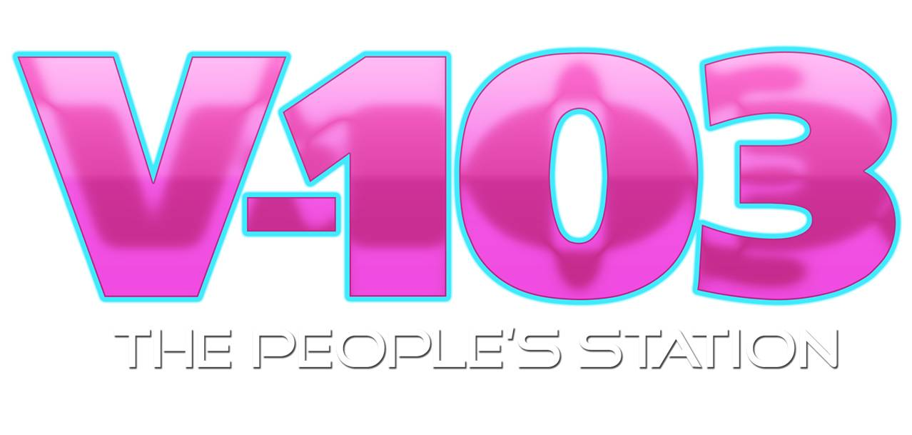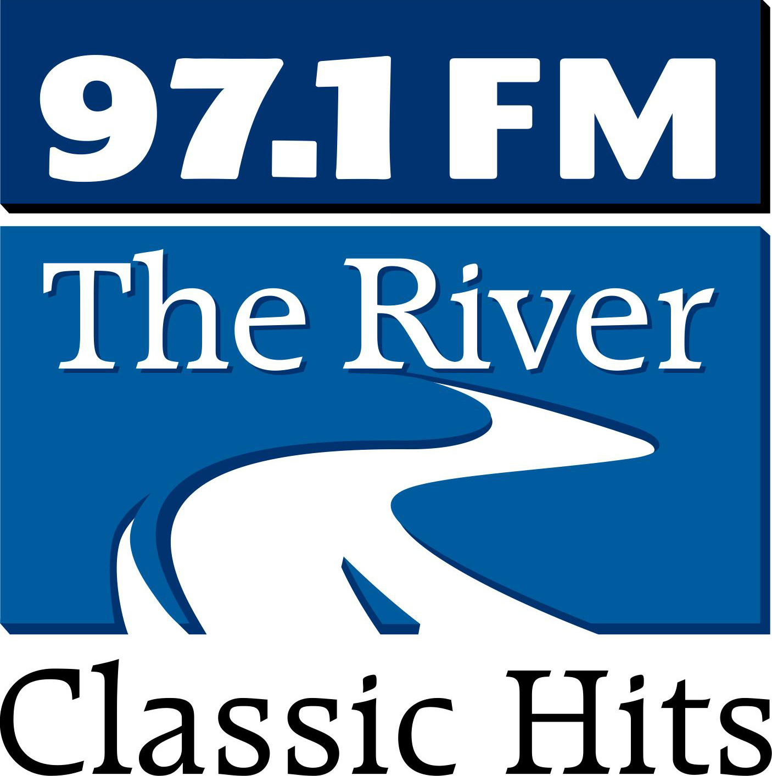`

6:00 **Welcome Ceremony**

Joel Helmke with WellStar

Vice President, Oncology Services

6:15 **Survivor Lap**

7:00 Zumba Class – Tomika Johnson

# 7:30 Greg Fortune – Singer

# Bubbles Lap

8:30 Danny Howell – Singer Show Your Holiday Spirit Lap

8:45 Charles Absher - Singer

Team Lap

9:00 Luminaria Ceremony

9:30 Seagull Readers Band

(Rains Draper, Robert Carter, Mason Arbery)

Glow Lap

10:00 Christiana Ekeke – Singer

Three Legged Lap

10:15 Greg Fortune – Singer

12:00 Closing Ceremony

**Event Chair**

*Sarah Beard*

**Bring the Fun Lead**

*Candice Rowe*

**Entertainment Lead**

*Cristina Beras*

*Lea Clanton*

**Accounting Lead**

*Elizabeth Hayes*

**Publicity Lead**

*Natalie Gonzalez*

**Committee Member**

*Mariana Bruno*

*Nancy Bracker*

Agenda

Relay For Life of Vinings Buckhead

Event Leadership Team

**Ceremonies Member**

*Erick & La’Techa Davis*

**Activities & Entertainment**

*Lisa Malone*

**Logistics Chair**

*Dan Sims*

**Fundraising & Sponsor**

*Dionne Maddox*

**Accounting**

*Lawanna Shepard*

**ACS CAN**

*Nelza Levine*