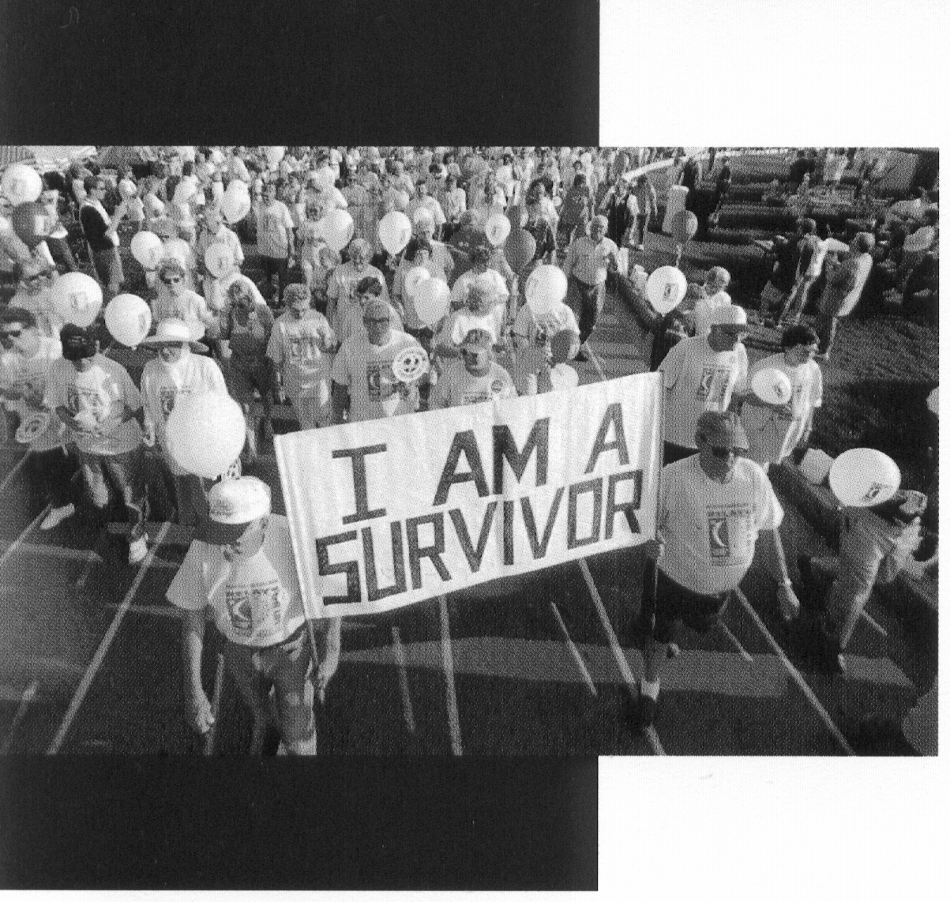
The Virtual Survivor

What is a Virtual Survivor?
A Virtual Survivor is a person that has been diagnosed
with cancer but cannot physically attend a Relay due to distance, time, illness, etc. These are the people in our lives that we CELEBRATE at Relay For Life, whether they can be with us at the event or not.

How Does It Work?
If you have a loved one who is unable to join us at the Relay For Life Opening Ceremony, you can still pay tribute to them. By creating a poster, photo, collage or t-shirt, you can honor them in the Opening Survivors Lap. You will be asked to join the 1st Lap, walking behind the Survivors, carrying or displaying your tribute to your Survivor who could not be at the Relay.
You will receive an official RFL Survivor T-Shirt to send or give to your Virtual Survivor after the walk. Or we can mail your Survivor their shirt after Relay.

What Do I Need To Do?
Register your Virtual Survivor by completing the form below and turning it in to the Virtual Survivor Chair, Natalie Bender at nbender@k-state.edu.

Why should I do this?
Relay For Life is all about Celebrating Survivorship. We know it can be hard to recruit Survivors in high school & college settings (this is a good thing!). But, we are all Relaying for someone special, through the Virtual Survivor program you can CELEBRATE the life of your loved one – even though they can’t be with you at the Relay. Plus, you will make them happy to know you are walking in their honor.

Your Name:

Team Name:

Name of your Virtual Survivor:

Address of your Virtual Survivor:

Type of Cancer: _______________ Diagnosis Date:____________

Survivor T-Shirt Size:

