

What is a Luminaria?
Relay For Life participants and donors remember loved ones lost to cancer and honor those battling the disease by dedicating luminaria bags.
Each luminaria has a name, photo, message or drawing in memory or honor of a friend or loved one who has been affected by cancer. Luminaria can also be dedicated in support of a Relay participant. Each luminaria candle represents a person. They are our spouses, children, mothers, fathers, sisters, brothers, aunts, uncles, nieces, nephews, friends, coworkers, and so many others. Anyone can decorate their Luminaria bag(s) to be displayed at their Relay For Life event and are welcome to join the Luminaria Ceremony at dusk.

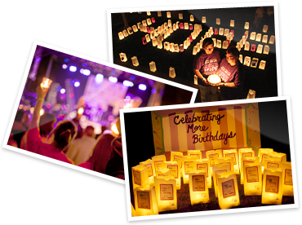
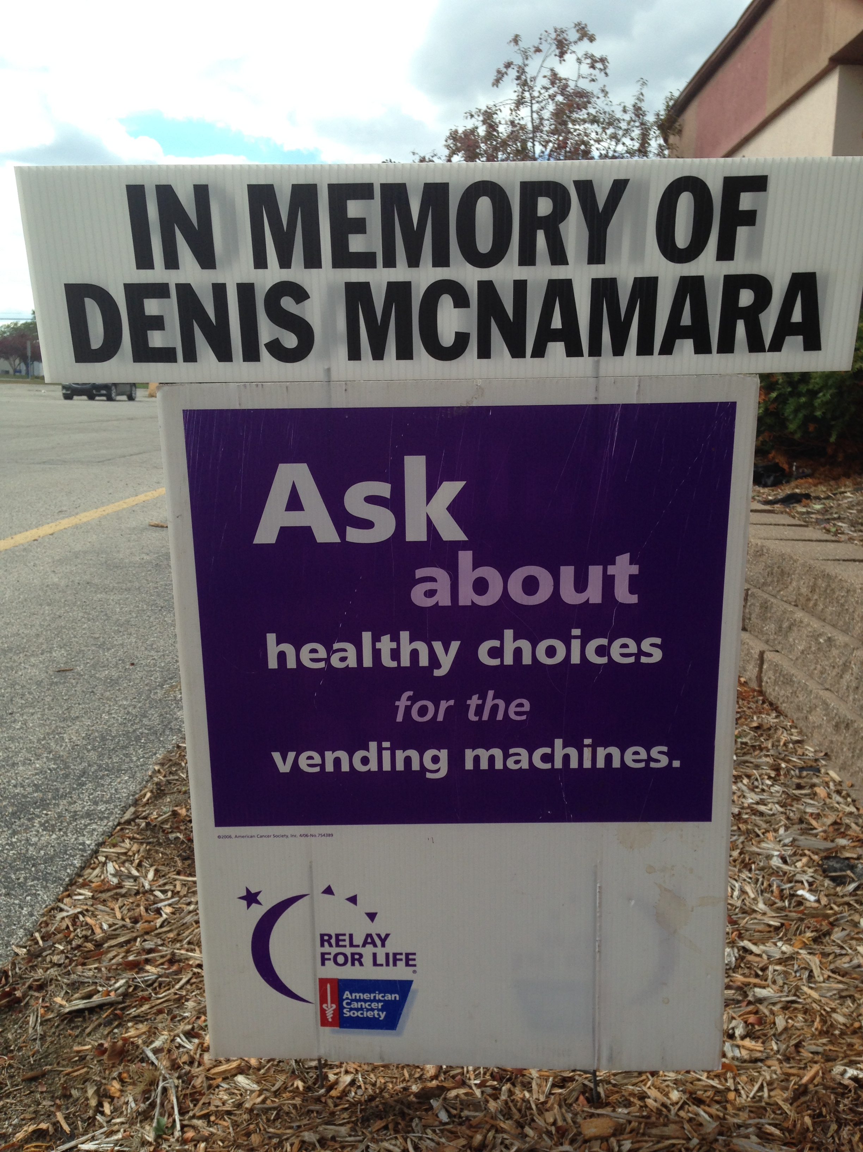
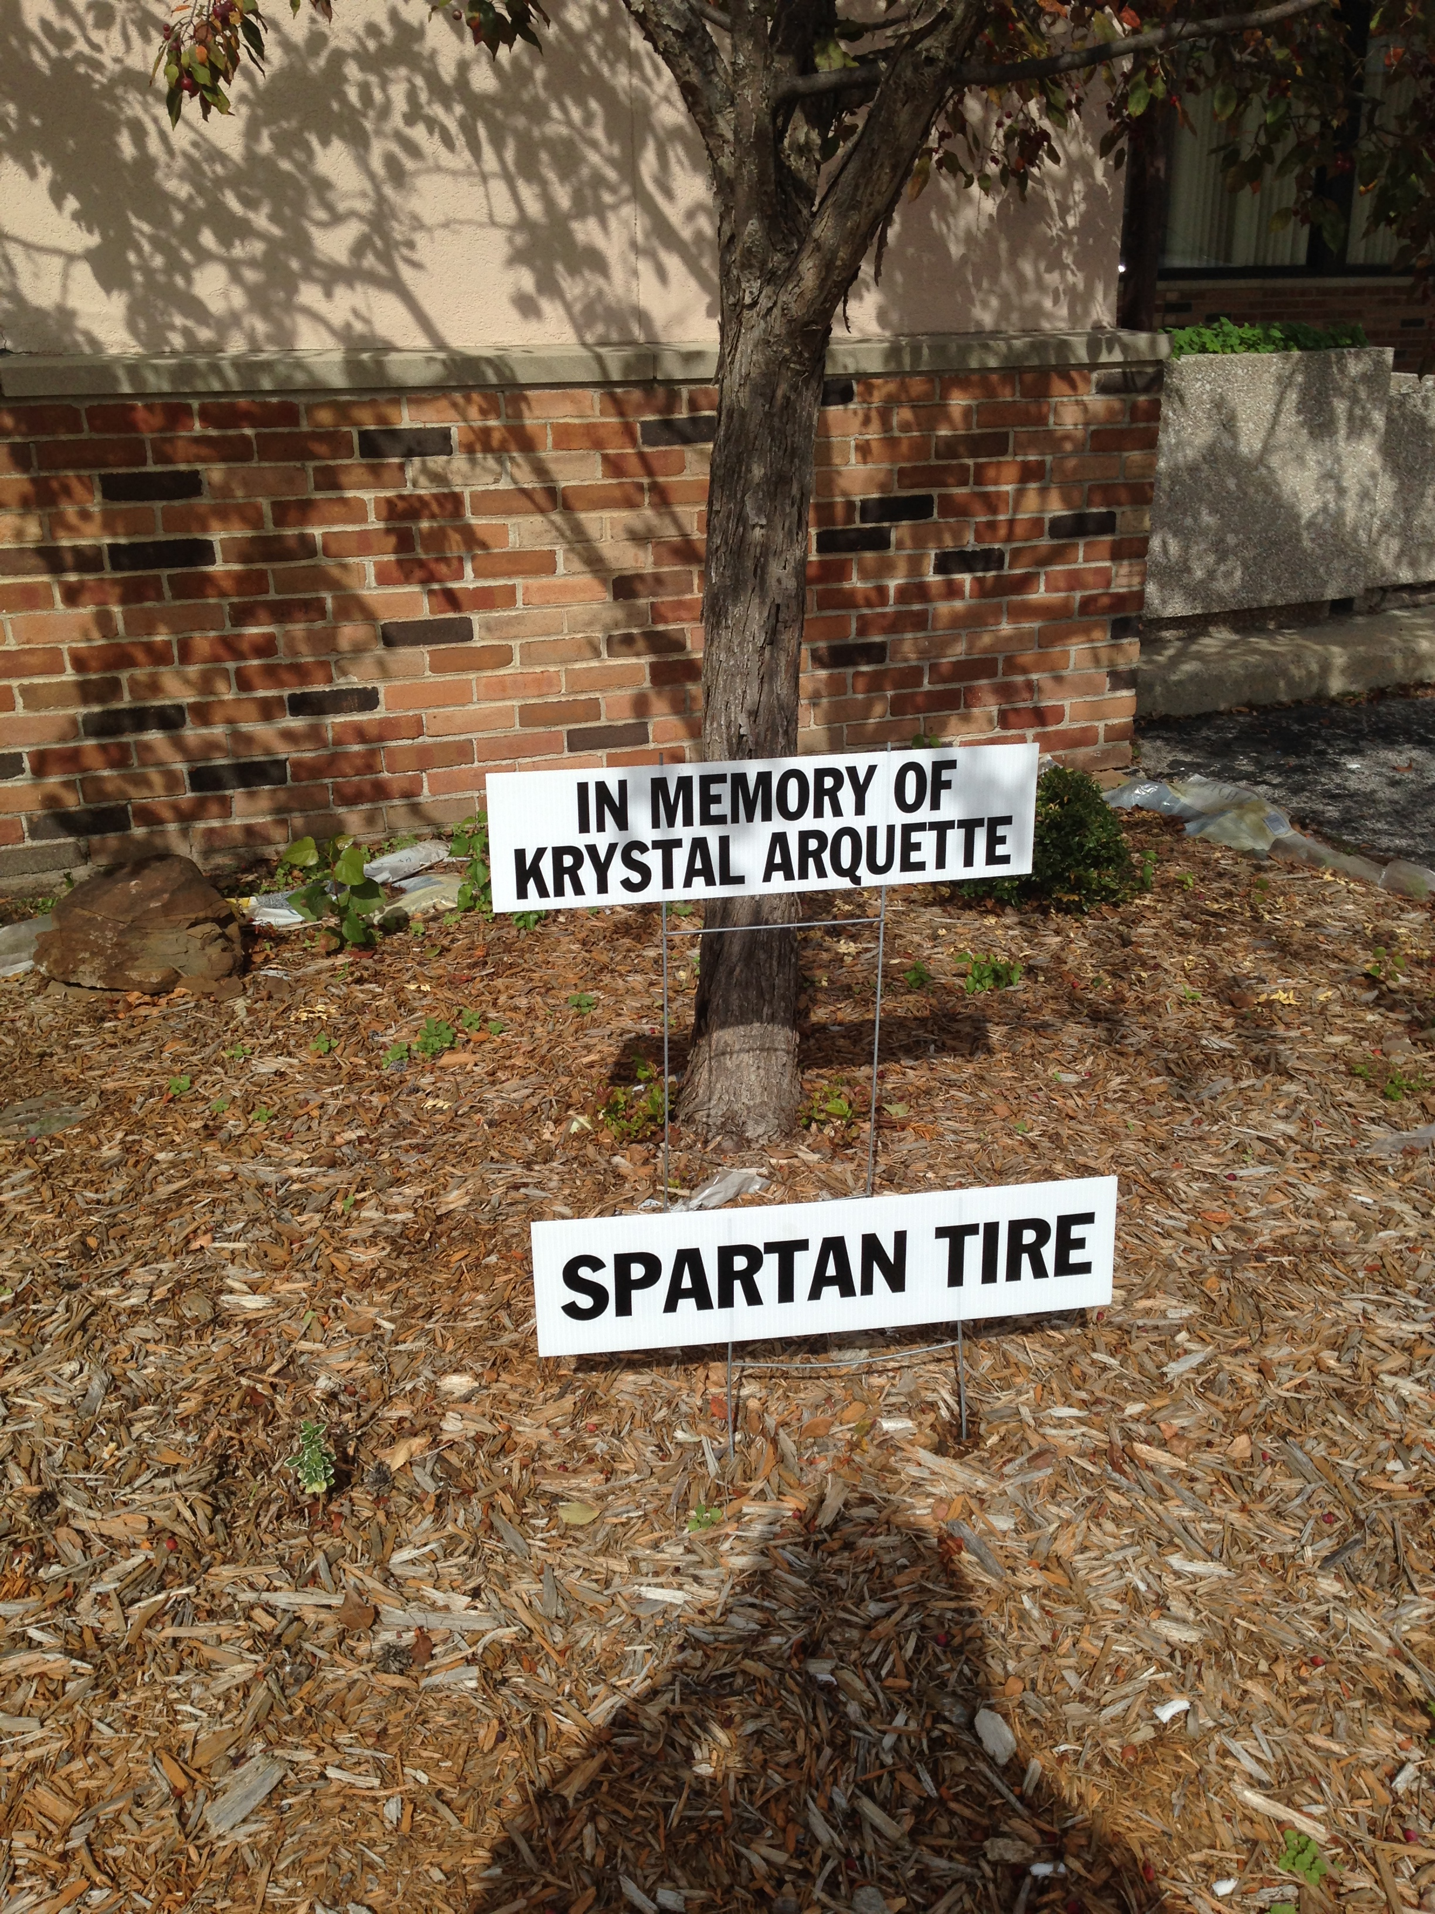
What is a Tribute sign?
Relay For Life participants and donors can remember loved ones lost to cancer and honor those battling the disease, or show their support to those Relaying to change the course of cancer by dedicating a Tribute sign.
Each Tribute sign will display message of “In memory” or “In honor” of a friend or loved one who has been affected by cancer up to 46 characters. Tribute signs can also be dedicated in support of a Relay participant or a community business that is changing the course of cancer. Anyone can purchase a Tribute sign(s) that will be displayed at their Relay For Life event.
Please join us at the Relay For Life of Bay County for the Luminaria Ceremony that will be held at 9:30 p.m. on May 21st, 2016 at Wenonah Park

RelayForLife.org/baycountymi

Give a gift to the American Cancer Society and keep the fire of hope burning with a tribute or luminaria in memory of someone lost to cancer, in honor of someone still fighting, or in special recognition of someone who has beaten this disease.
The suggested donation amount is
$10.00 per Luminaria $100.00 per Tribute

Enclosed is my total gift of $
#of Luminaria: _________
❑ In Honor of:

❑ In Memory of:

# of Tribute: __________
❑ Tribute (Up to 46 Characters that may include one name or one business)

Team: _________________________________________________________________________
Participant: _____________________________________________________________________

Name: ________________________
Address: ________________________
City:______________________________ State: Zip: __________________
Phone: ___________________________ Email: _____________________________________
Please check ONE:
❑ I will create my own luminaria bags and return it or bring it to the Relay For Life.
❑ I would like the team to create my luminaria bags on my behalf.
(Please make all checks payable to the American Cancer Society.)
❑ Cash  Check  Credit Card
Payment by:  American Express  Visa  Master Card
Card Number:________________________________________ Exp.Date: _______________
Signature:___________________________________________________ Date: ____________

