DISPLAY YOUR BUSINESS CARD IN A 2017 PROGRAM

Donate $100 and we will include your business card in the 2017 Relay For Life of Tehachapi program.

- All business card donations 100% tax deductible

Then return the Business Card Supporter Form, business card and the $100 donation to the office address below.
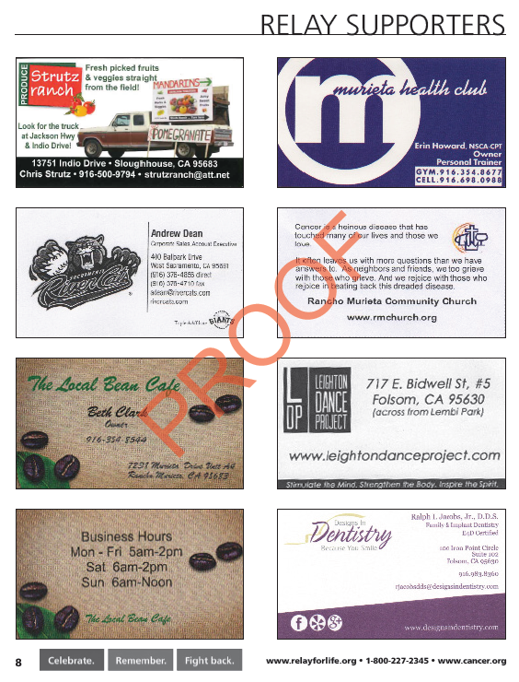

Return this form, business card & $100 donation to:
American Cancer Society
1831 Truxtun Ave Suite 150
Bakersfield, CA 93312
Or Give to Relay Participant
For questions contact: American Cancer Society, Donna Hermann 661-327-7827
Relay For Life of Tehachapi

Please complete the Business Card Supporter Form and attach
the business card with a paperclip and the $100.00 donation
and place it in your participant collection envelope.
THIS FORM MUST ACCOMPANY YOUR CARD AND PAYMENT.

All cards must be turned in by June 15, 2017 to be included in the program.

Participant Name:____________________________________________ Phone #:_____________________
Team Name:________________________________________ Team Captain:________________________
Name of Business:______________________________________________________________________

Permission given by business to print in 2017 program? Yes  No 

---------------------------------------------------------------------------------------------------------------------------------------

Relay For Life of Tehachapi

Please complete the Business Card Supporter Form and attach
the business card with a paperclip and the $100.00 donation
and place it in your participant collection envelope.
THIS FORM MUST ACCOMPANY YOUR CARD AND PAYMENT.

All cards must be turned in by June 15, 2017 to be included in the program.

Participant Name:____________________________________________ Phone #:_____________________
Team Name:________________________________________ Team Captain:________________________
Name of Business:______________________________________________________________________

Permission given by business to print in 2017 program? Yes  No 

