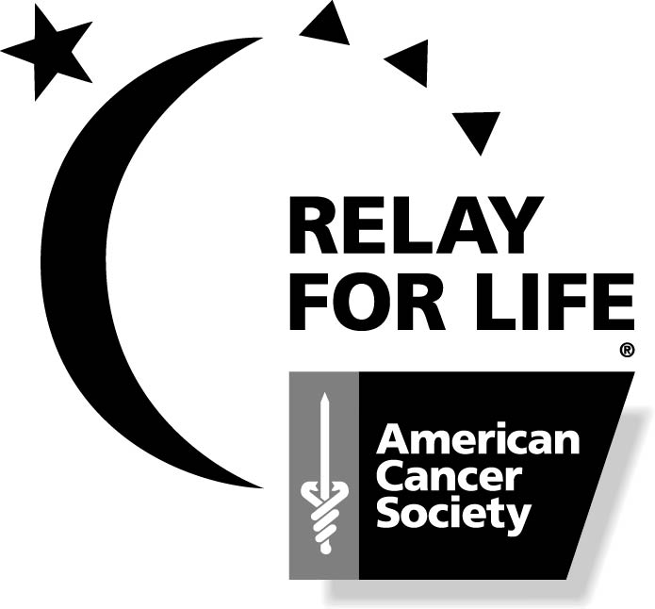On Saturday, June 4th, 2016 the Opening Ceremonies of the American Cancer Society’s Relay For Life, a Celebration of Life, will begin at 4:00 p.m. with cancer survivors completing the first lap. This year the Luminaria (votive candles in paper bags with bird seed) will be lining the track area. The Luminaria will be lit in memory and honor of loved ones and friends who have had cancer. The Lighting Ceremony will begin at 10:00 p.m., and everyone is invited to attend.

We want to give everyone an opportunity to pay tribute to their loved ones and friends and help fight the disease that claims so many lives. You do not need to be an actual participant in the celebration to take part in this tribute. With your donation, the name of the individual you designate will be placed on a luminaria bag to be lit on Saturday evening.

If you would like to participate in our candle lighting, clip and send the form below. Completed luminarias will be placed around the track by volunteers and relay teams the day of the event. Please come and join us!

White Bags - $5.00 Gold Bags - $20.00

Thank You.
------------------------------------------------------------------------------------------------------------------

Please light a candle in memory or honor of my loved one/friend who has had cancer. I understand the proceeds will benefit my local American Cancer Society.

PLEASE PRINT

In Memory Of: _________________________________________
Amount Enclosed________________

In Honor Of: ___________________________________________
Amount Enclosed________________
(A Cancer Survivor)

Please list the name of the team or team member you would like for this contribution to be accredited to:

___________________________________________________________________________

Send form with your contribution of $5.00 for white bag and $20 for gold bag to:
Smyth County Relay For Life
American Cancer Society
PO Box 246
Abingdon, VA 24212

PLEASE MAKE ALL CHECKS PAYABLE TO THE
AMERICAN CANCER SOCIETY

