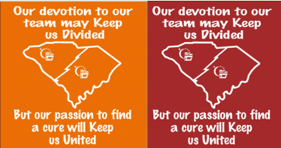
Renwick “We’re United Shirts” Fall Design

Renwick has a new shirt design and it's a great way to show our state unity. The recent events in SC have shown that we truly are a state that comes together under difficult circumstances. Relay unites us all. It doesn't matter if you're a Clemson or Carolina fan, the team we pull for is the Relay team! We are united in the fight against cancer. Say it loud and say it proud South Carolina!
These shirts are only available in long sleeve until December 31 so it's important that you place your orders now. We will then have a new design for the Spring. The shirts will sell for $15. They will cost us $10 so we will make a profit of $5 per shirt.
The order deadline dates are as follows:
- 11/3
- 11/17
- 12/1
- 12/15
- 12/29
Orders can be turned in at Chick-Fil-A from 5:30-7 pm on these dates. Julie Keith and Katherine Dixon will be there to take your orders.

- These are CASH only sales. No checks can be accepted.
- Please use the attached Excel spreadsheet and fill in the Quantity.
- The spread sheet will compute the totals for you. (team amount and the amount we owe to Renwick)
- Separate your money into the 2 amounts- TEAM amount and RENWICK amount. Make sure you have the correct change since we may not be able to make change. The spreadsheet tells you these 2 amounts.
- We will not accept forms that are written in to ensure that the totals are correct and to speed up the order process at Chick Fil A.
- Print off a copy to turn in 1 and keep one for your records.
- Please print your order on 1 sheet only. You may have to adjust your printing to SCALE it to one page. Print it landscape not portrait style.
- Orders will be returned in 2-3 weeks depending on the volume of sales statewide.
- Fill out an accounting sheet for the TEAM amount. This is the amount you will be credited.
Contact Julie Keith at jkeith920@gmail.com or Katherine Long at katherine.long@kcsdschools.net for any questions you have concerning these orders. Julie and Katherine are our Fundraising Leads this year. They will be happy to assist you.

