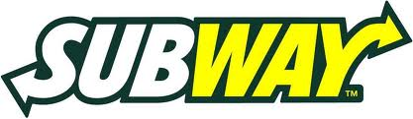
SUBWAY SPIRIT NIGHT
98 N. 10th St. Subway - Downtown
Relay for Life of Noblesville
March 19 & 20
5 – 9 PM both nights
DATE: | AMOUNT SPENT: $

Relay for Life of Noblesville receives 10% of all items on dine in and carry out. Please fill in date and amount spent when paying for your order. Thank you for your support!

SUBWAY SPIRIT NIGHT
98 N. 10th St. Subway - Downtown
Relay for Life of Noblesville
March 19 & 20
5 – 9 PM both nights
DATE: | AMOUNT SPENT: $

Relay for Life of Noblesville receives 10% of all items on dine in and carry out. Please fill in date and amount spent when paying for your order. Thank you for your support!

