Relay for Life of Baldwin County 2017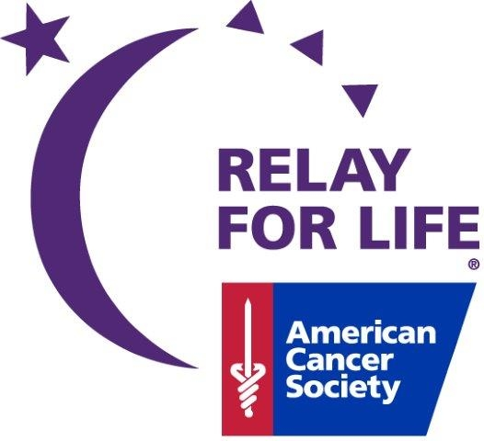
Cancer: not here, not there, not anywhere

Time | Activity
9:30AM-2:30PM  3:30PM-6:00PM | Team Check In and Set Up
6:00PM-6:30PM | Midway Drill Team Performance
6:30PM-7:00PM | Opening Ceremony- survivor/caregiver lap, sponsor lap, team lap  Followed by the Reading of Horton Hears a Who and then our Noise Lap
7:00PM | Participants can begin sign up for Buffalo Wild Wings Challenge.  Open to first 10 participants.
7:15 PM | Children’s Lap followed by Costume Lap
7:30 PM-8:20PM | Zumba
8:30PM-8:45PM | GC Pep Band
9:00PM | Wild Wing Challenge Participants Report to Information Tent to sign waivers
9:00 PM-9:15PM | ACS CAN Lap (All ACS CAN Members meet at the information tent at 8:55PM)  Conga Lap  Purple Passion Lap
9:15PM | Buffalo Wild Wings Challenge will begin
10:00 PM-10:30PM | Luminaria Ceremony
10:30 PM-11:00PM | Scavenger Hunt (Announcement will be made shortly after Luminaria Ceremony ends to report to tent to participate)
11:00 PM-11:30PM | Line Dancing and random fun laps (No preparation needed!)
11:45 PM-Midnight | Closing Ceremonies  Award Winners will be announced during Closing Ceremonies

2017 Corporate Sponsors

Platinum Level: Mohawk
Gold Level: Zschimmer & Schwarz and Beckham’s Used Cars
Silver Level: Century Bank & Trust, Southeast Powergen, LLC, and Georgia Cancer Specialists
Bronze Level: Triumph Group and Robins Financial Credit Union
Signature Level: Childre Nissan
Media Sponsors: Leslie Outdoor Advertising, 103.9 The Dock, and Redline Aerial Photography
In Kind: Georgia Military College, Evergreen Storage, Buffalo Wild Wings, and
Milledgeville First United Methodist Church

