The Riverview Relay for Life invites you to join us in a race for the cure!

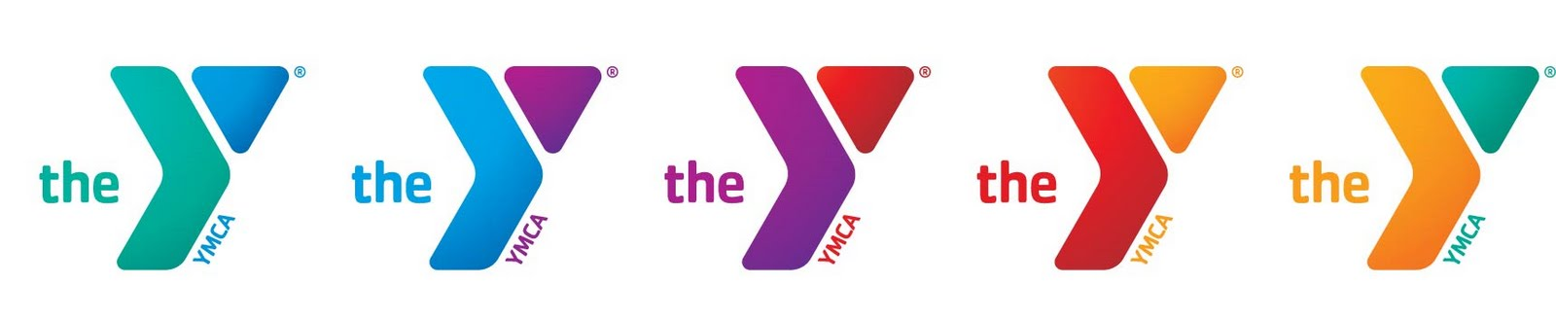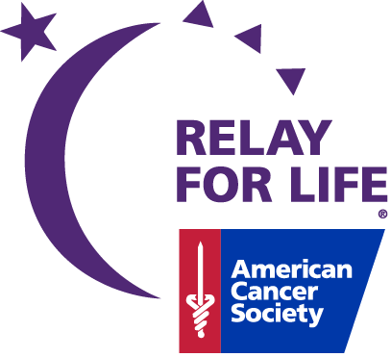

- Early registration: $ 20/person\*

\*Register by January 21st to get an event T-shirt (cash only)

\*$12/person goes to your team page

\*Register at Campo YMCA (3414 Culbreath Road, Valrico 813-684-1371, Contact: Sandra or Kavita)

- Registration (day of the event):

$25/person

Fees Include:

* Challenge Course Entrance
* Breakfast provided by

Chick-Fil-A

Obstacle Course Information:

* Archery
* Zip Line
* Climbing Tower
* Orienteering
* Challenge Course