Relay For Life of Western Berks
01/12/2017 Meeting Agenda
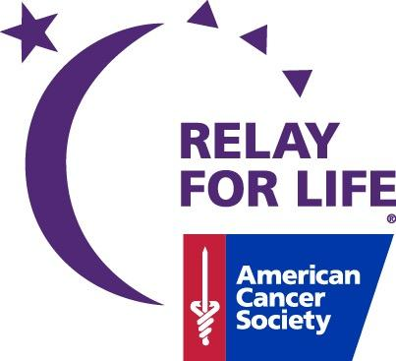

- Welcome! Thank you to Berks Eye for dinner

- Icebreaker and Delegation Discussion Jayme
- Roundtable Discussion
- Tonight’s Topics-Fundraising, Day of Event Fundraising onsite, Activites and Entertainment and Sponsorship
- Thank you for all the positive feedback, all notes received tonight, we will use for future team building activites etc
- Mission Linda-
- National Cervical Health Awareness
- Healthy Weight Week
- Team Recognition: Mandy
- Welcome back Remission Possible and Angie’s Kids
- New challenge for January-Register the most team members till the next meeting. Team who registered the most team members will win a prize!!
Participants_____237________

Teams______40__________

Survivors_____34_________

Luminaria_0__Time to start selling!! Contact Crystal Weller for bags and information!!

ACS CAN____115__________

Event______$42,232__________
- Chef Tim’s Table is back! Each time a survivor attends one of our events, they will be entered to win a dinner in the kitchen at Prime Steak with the fantastic Chef Tim Twiford! This month’s winner is Melissa Frantz
- Upcoming Events and Fundraisers: Kat
January 16th- Berks Office Closed
February 10th-Deadline for Daffodil Days
February 12, 2017 – Vendor Bingo @ Leesport Farmers Market, 2PM *Tickets can be signed out, help is needed day of event*
February 18, 2017 – Pink in the Rink @ Reading Royals
March 15th- Help needed at ACS Office to sort Daffodil orders
March 16th- Daffodil pick up!
March 17, 2017 – Deadline for Pellman’s and Candy Sale (Pickup 4/13)
March 25, 2017 – Paint the Parrot Purple Party w/ Jimmy and the Parrots!
Online tickets: http://bit.ly/ParrotWB
April 23, 2017 – Kauffman’s Chicken BBQ
May 21, 2017 – Colors of Cancer 5K (Details Coming)

- American Cancer Society Updates: Barb
- Daffodil days are back, forms and information are available.
- Go local app is coming, this app will have local businesses on it with coupons just like the kid stuff coupon books the kids sell. The app is $20 and $15 comes back to the Relay teams for each one sold. Coupons available for all over. Definitely something to check out!
- Next Meeting: February 9th at 6:30 PM
A Huge Thank You to our 2017 Sponsors!
B & G Electric, Carpenter Technology, Customer’s Bank, Grove Dental, Penn National Gaming, Reanimated Art Tattoo Studio, Tompkins Vist Bank, W.F Naugle & Sons

How Can We Help?
Shawn Pauley - Event Lead | me@shawnpauley.com
Erin Work - Bring The People Lead | elwork613@gmail.com
Tina Wiatrowski - Build The Fun Lead | Tina.wiatrowski@gmail.com
Linda Capellupo - Fund The Mission Lead | llcapellupo@gmail.com

