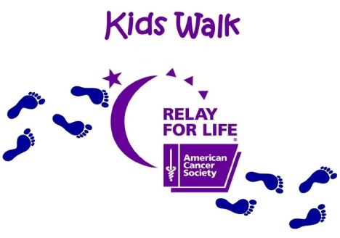
Kid's Making a Difference in the Fight against Cancer”
2017 Relay for Life of Nash County Kid’s Walk
Rocky Mount Sports Complex
Friday, April 28, 2017
Kid’s Walk will begin at 5:00 p.m.

Child’s Name: __________________________________________________________________

School or Team Name: __________________________________________________________

Parent or Guardian’s Name: ______________________________________________________

E-mail address: ________________________________________________________________

Address: _____________________________________________________________________

City: ______________________________State________________ Zip: _________________

Phone: ___________________________________Age of participant: ____________________

Survivor: (circle) Yes No

T-Shirt size: (circle) YS YM YL S M L XL XXL

I further release the American Cancer Society from liability with respect to any injuries or damages of any kind whatsoever suffered as a result of taking part in the event and any related activities.

Parent/Guardian Signature: ______________________________________Date:________________________

Each child will need to join the “Kids Walk” team by registering at www.relayforlife.org/nashnc
AND try to raise $25.00 or more for the “Fight against Cancer”.
Registration deadline for ordering T-Shirts: Friday April 7th, 2017

One Girl and One Boy who raises the most money for “Kids Walk” will be crowned the “King and Queen” of Nash County Relay for Life 2017. To be considered “King and Queen”, all monies must be turned in at the event or credited to the RFL website under the Kids Walk team by 4:30pm on Friday, April 28th, 2017.

For more information please contact Sherry Harris (252-366-2917) or email to sherry.harris@centurylink.com please make all checks payable to American Cancer Society or Relay for Life of Nash County IF you are UNABLE to register online, please return completed registration form by mail to: Sherry Harris, 419 Woodfield Drive, Nashville, NC 27856.

