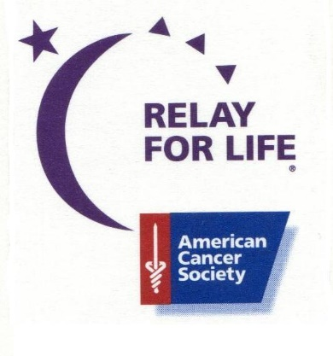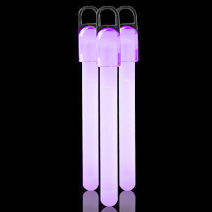
Purple Glow Stick Light Up the Night Fundraiser
Relay For Life of Kershaw County

It’s a special way to participate in our Luminaria ceremony this year. You can purchase PURPLE glow sticks and help us LIGHT UP THE NIGHT!
Purple glow sticks are 4 inches in length. You can hold them up high to honor and remember those affected by cancer during our Luminaria ceremony at Lugoff-Elgin High on Friday, May 12, 2017 at 9:30 pm. We will be selling them until May 5 and distribute them to teams on Bank Day, May 8 so you will be ready to participate in our Luminaria ceremony.
Cost is $2 each. All proceeds benefit Relay For Life of Kershaw County.
Quantity_______ Amount $________

Team:________________________Member:_______________________

