

COME OUT AND SUPPORT OUR GROUP!!! WE ARE HAVING A FAMILY NIGHT TO RAISE FUNDS AT THE LISBON PIZZA HUT FOR:

American Cancer Society’s Relay for Life of Western Howard County

lISBON PIZZA HUT

706 Lisbon Center Drive

410-442-1473

Dine-in & Carryout

Time: 5 PM – 9 PM
Date: Wednesday December 3, 2014

That’s right, no matter if you’re craving Pizza Hut Pizza, Pasta or Wings you can show your support if you Dine-in or Carryout! Just present this flyer when you pay and our group will earn up to 20% of the net sales of your transaction.

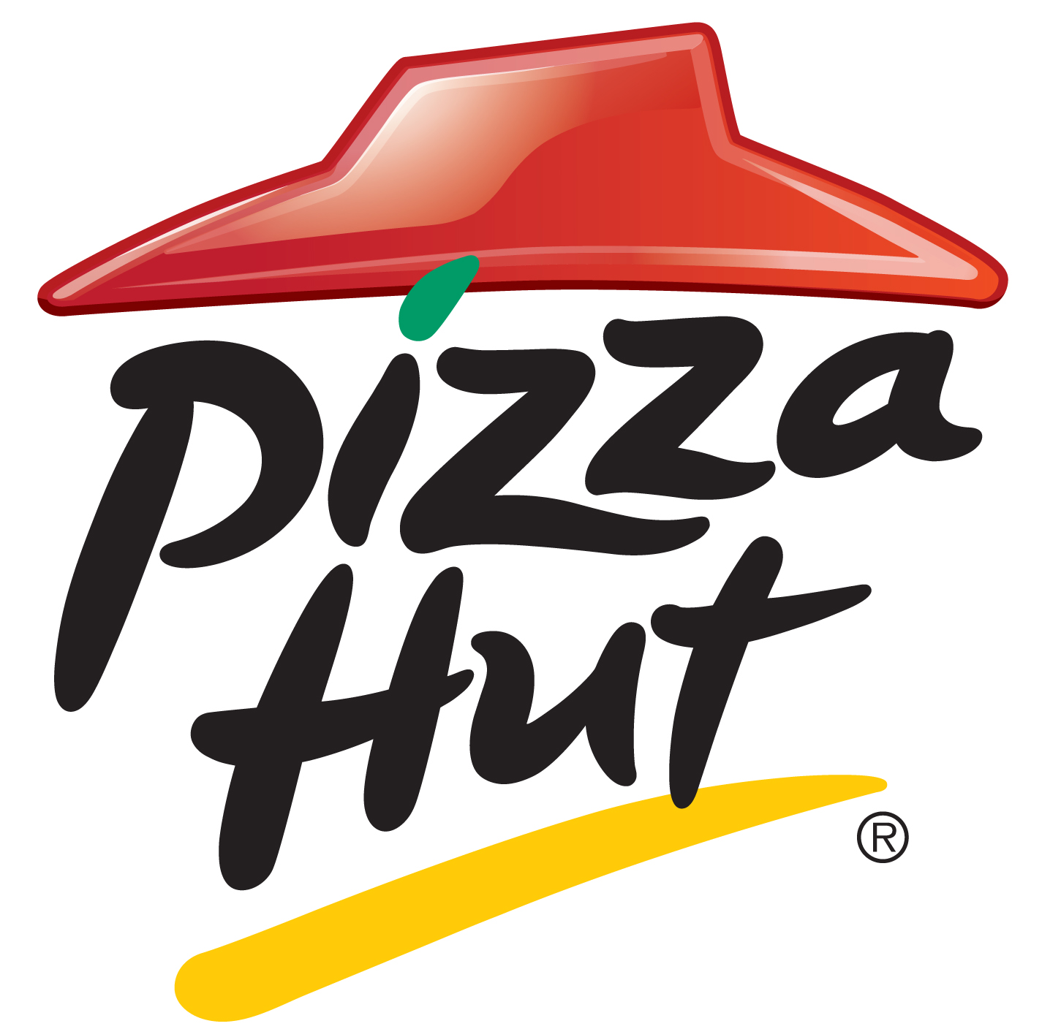FUNDRAISER PLEASE PRESENT THIS FLYER
WITH PAYMENT AT THE LISBON PIZZAHUT (5-9PM) ON 12/3/14

