Relay for Life Event Need to Knows
2015 Relay for Life of Norfolk
May 30-31 Noon – 1 AM
Lake Taylor High School

What if I have questions during the event? Visit the registration/information tent at the main entrance. It will be manned for any information/questions you may have during set up and throughout the event. You may also approach any committee member (look for the green shirts) for assistance.

If there is a problem or emergency, where should I go or who should I look for? Any problem or emergency needs to be communicated to the Event Chair, Pam Murray, or ACS Staff Person, Jonell McDonnell. If it is a medical emergency proceed to the First Aid Station located at the EMS Campsite (by the main entrance to the field). There will be emergency personnel there to assist you. In addition, you can ask for assistance from anyone in a green t-shirt. If you have an emergency and you are not able to get to the First Aid Station and need assistance immediately call 757-618-7448 or 757-892-4285 and we’ll have them come to you.

When can teams begin to set-up? Teams can begin setting up on Saturday, May 30 from 10:00 AM until 12:00 PM. If you have a tent company setting up a tent, they can begin setup at 8:00AM.

Why is the field roped off? Lake Taylor High School is preparing the field for the summer practice and fall football season and has asked that we keep all participants off of the field for the duration of our event. We ask that everyone respect the tape and make every effort to remain off the field.

Where should I park? SURVIVOR, HANDICAP and VIP parking will be at the middle school lot on the left when you are facing the building (closest to the track). Committee and volunteers will park in the rear and side lots of the middle school. General parking will be in the middle school lot to the right of the building near the baseball field and at the high school side and rear lots.

We will have a drop off only area in the middle school lot – directed by the parking attendants. This is strictly for drop off only; please stay with your car. Someone from your team who is already on site MUST meet you to grab belongings from your vehicle. No parking is allowed in this area, this will be a quick stop only.

Red Arrows represent Survivors/Handicap/Committee/VIP parking
Green arrows represent general parking.
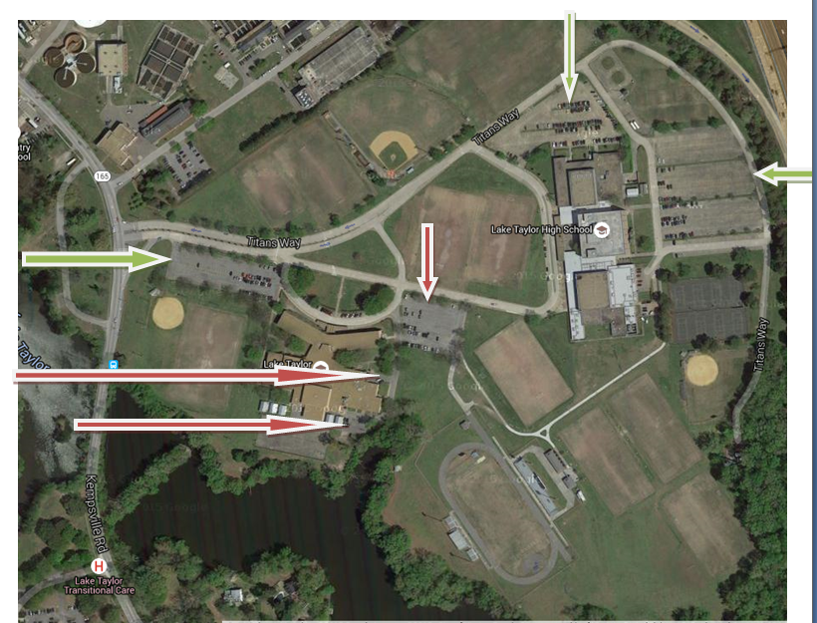

Where can I set up my campsite? If you do not know your campsite number, check with the registration/information tent at the main entrance and they can give you your campsite information. You must set up on the campsite you have been assigned. Do not switch campsites. If there is a problem with your campsite please contact the information booth or any committee member (green shirts). If you have ordered a tent via Special Events or other vendor please email that information to us prior to the event at NorfolkRelay@yahoo.com.

Can my campsite use tent stakes? NO! Please arrange for sandbags or water jugs to hold your tent in place.

Will I have electricity? Most campsites will not have electricity this year. If you need electricity, plan on bringing a generator. Also please be sure that you have notified Allison Elkins or Tracy Hayes before receiving a campsite. If you bring a generator, plan to shut if off from 8:45 PM -9:45 PM during the Luminaria Ceremony.

What should I bring? Please check the event website or the Team Captain kit you received when you registered for helpful hints on what to bring.

Where are the bathrooms? Check out the map in the registration/information tent at the main entrance for directions. We have a set of bathrooms located near the concessions stand.

Do I need to bring bathroom supplies? We will provide toilet paper, paper towels and soap for the bathrooms, however we do encourage teams to bring a backup supply and to bring hand sanitizer as well.

Can I bring my charcoal grill? Charcoal grills are NOT permitted. Please place grills only on designated areas (contact Tracy Hayes for more information). Be advised that you MAY NOT sell food from your grill unless you have filled out and submitted the temporary food permit application to the health department, however you may cook for yourself or your team. Fire extinguishers are also required for any camp using a grill. Health Department information may be obtained from Lucy Ott at NorfolkRelay@yahoo.com.

Can I bring my camper? Unfortunately, there is no way for us to get pop up campers onto your campsite. No vehicles are allowed to cross over the track, per the school’s request.

Can I bring my pets? Due to insurance regulations, no pets are allowed at the event, unless they are a certified guide dog for the impaired. All other pets must remain at home. We’d love for them to participate in an American Cancer Society Bark for Life event- call 493-7940 for more information!

Can I rollerblade, skateboard or bicycle around the track? For the safety of all of the participants, we will not allow anyone to skateboard, rollerblade, or bicycle on the track. Wheelchairs, walkers, strollers and wagons are permitted.

Can we have alcohol at the event? Alcohol and tobacco products are strictly forbidden at any Relay for Life event and on school property. Anyone consuming alcohol or smoking/chewing will be asked to leave.

Do Team Captains need to Check-In? Team captains should check in at the registration/information tent at the main entrance. If you have not picked up t-shirts you can get those there. You can also see where your campsite is located if needed. Volunteers in the registration tent will be able to assist you.

When does the Opening Ceremony Start? The Opening Ceremony begins at 12:00 noon. We ask that all participants gather in front of the stage for the ceremony.

Where do Survivors go when they get there? The Survivor & Caregiver registration will begin at 10 AM at the registration tent. The Survivor and Caregiver lap will conclude the Opening Ceremony, which starts at 12 noon. The reception will begin immediately following the lap, around 1 PM. Each survivor may bring one caregiver to the reception. Note that our survivor reception will be in the Lake Taylor High School cafeteria. The walk to this location will take several minutes. If you are unable to walk to the reception, contact one of the committee members for alternative solutions (volunteers in green shirts).

Will there be security Saturday/Sunday? Yes, we will have Sheriff’s Deputies on site throughout the event from Saturday morning to Sunday morning.

When and where can I turn in money that night? Accounting will be open on Saturday, May 30 from noon until 1AM Sunday, May 31. The Accounting area will be at the stadium’s ticket booth. The last day to turn in money at the ACS office in Virginia Beach before the event is Wednesday May 27, 2015. This allows ACS to catch up on data entry and have the most accurate data as we go into our event. After Relay, you may again turn in donations at the office for this year’s event through August 31. We will also have one or two bank nights after Relay to collect donations. Dates will be communicated through email, our website and Facebook page.

When can I pick up my team’s T-shirts? If you did not pick up your team’s shirts at the May 14st Relay Rally, please come to the registration area at Relay to pick up all of the shirts for your team members who were registered and qualified for by the deadline (April 20). Individual shirts willnot be given out at registration.

Can my team members who did not receive a shirt get one at Relay? Contact jonell.mcdonnell@cancer.org or call 493-7953 if you have a team member who has raised $100 and does not have a t-shirt.

What happens if it rains? Relay does not stop for nighttime or rain. If it is raining, the Relay will continue on as planned. In the event of severe weather (lightning, tornado threat, etc.) announcements will be made from the stage on how to proceed.

Will there be food there to eat, or should I eat beforehand? Several teams will be selling food or you can bring your own food. Free food will be provided to all Survivors and Caregivers (one Caregiver per Survivor) at the Survivor and Caregiver reception. Thank you Pollard’s Chicken and Catering for providing the food.

Do I really have to stay all night? We understand that some people will have to leave the Relay to go home. We ask that as many people that can stay, do stay until the Closing Ceremony at 1:00 AM. We also ask that at least one representative from your team be on the track at all times.

Can I leave and come back? You may leave the facility and come back, but those under 18 must abide by the city curfew and plan ahead.

Where do I get supplies for my luminaries? Sand will be delivered to the event and placed on the long jump pit. Candles and bags will be in the registration/information tent at the main entrance. Be sure to bring a shovel, bucket and wagon for prepping your Luminarias and a long handled lighter for lighting your candles.
Sunday morning everyone will empty the luminaria bags of sand returning it to the long jump area, dispose of the candle/glow sticks, and bag in the closest trash receptacle.

What do we do with our trash? Campsite maintenance is highly encouraged. It is not the responsibility of committee members to clean campsites. Dispose of your trash in the receptacles provided. You will receive a trash bag in your team captain bag at t-shirt pick-up. If the trash receptacle closest to your campsite is full, replace the bag and someone will be by to pick it up. Empty your beverage containers before throwing them in the bins. Sunday morning everyone will empty the luminaria bags of sand, dispose of the candle/glow sticks, and luminaria bag in the closest trash receptacle. Make sure you pick up any luminaries you would like to keep by midnight. Do not throw the sand in the trash or on the field. Sand should be returned back to the long jump pit. Your assistance in trash control will be greatly appreciated!

What time do I need to be off the field on Sunday morning? Everything must be off of the field by 2 AM on Sunday, May 31. We will open back up for rented tent removal from 10:00 AM to 2:00 PM on Sunday, May 31st. Make sure your rental company is prepared to pick up during those hours. If you have rented a tent from a company and they are not able to remove it by that time, notify a committee member.

What about money I collect after the Relay? It can be turned in to the American Cancer Society office or mailed to the ACS Office at 4416 Expressway Dr., Virginia Beach, VA 23452. Do NOT mail cash or coins – checks, cashier’s checks, or money orders only. Money for this year’s Relay will be accepted until close of business August 31, 2015.

When will I get my Incentive Prize for the Nationwide Individual Fundraising Club? Incentive certificates will be e-mailed approximately 2-3 weeks after the event. For those who do not have an e-mail address, the certificates will be mailed by USPS. Each individual who has raised enough money to qualify will receive ONE certificate that can be used on any ONE prize at that level or a lower level. If your team chooses to combine certificates for one of the higher level prizes, you must turn in your certificates to the team captain who can then enter all of the codes through the incentive website to redeem the larger prize.

What are the Nationwide Team Fundraising Club levels? The Nationwide Team Fundraising Club is a program in which we recognize teams for achieving certain levels of fundraising. Rising Star: $1,000 - $2,499; Bronze Level: $2,500 - $3,499; Silver Level: $3,500 - $4,999; Gold Level: $5,000 - $7,499; Platinum Club: $7,500 - $9,999; Jade Level: $10,000 - $14,999; Sapphire Level: $15,000 - $24,999; Emerald Level: $25,000 - $34,999; Ruby Level: $50,000 - $74,999; Purple Level: $100,000 Turquoise $200,000 - $249,999; Titanium $250,000 – $499,999; Cure Club $500,000+. Signs and stickers to update the team levels will be located at the registration area.

New this year – ACS Fundraising App



