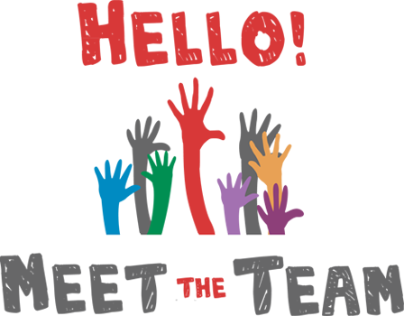

ACS STAFF PARTNER
JENNIFER CLARK W 802-872-6323/C 802-309-9763 JENNIFER.CLARK@CANCER.ORG

EVENT LEAD
DENA ST AMOUR C 802-249-1259 DSTAMOUR@FNWSU.ORG

MISSION EDUCATION & ADVOCACY
KATHLEEN HOFFMAN C 802-582-0734 LOVEROFSHAKESPEARE@GMAIL.COM

COMMUNITY ENGAGEMENT
CONNIE REED C 802-782-2379 CSRC0200@YAHOO.COM

FINANCE
JAMES CORBIN C 802-238-5872 JCFIGURE@GMAIL.COM
JANET KNUTSEN C 802-309-8658 JBKNUTSEN@AOL.COM
CARRIE BEAUREGARD C 802-578-3166 CAC1221@HOTMAIL.COM
KEN ST AMOUR KEN-STAMOUR@COMCAST.NET
ONSITE FUNDRAISING (BASKETS)
PAM HAKEY H 802-868-7886 PAM.HAKEY@UNILEVER.COM

REGISTRATION & VOLUNTEERS

STAGE ENTERTAINMENT
JAMIE PINKHAM C 802-785-8566 JPINKHAM@NMCINC.ORG

SURVIVORS/CAREGIVERS
PENNY SHEDRICK C 802-782-5107 SHEDRICKPENNY@YAHOO.COM
MARIE MASKELL H 802-868-2108 CANDLE_LADIE04@YAHOO.COM

LUMINARIA
DEVIN LUMBRA C 802-582-0806 DEVIN82@MYFAIRPOINT.NET
BRIAN ROLLINS C 450-204-0221 BRIANROLLINS@HOTMAIL.COM
NICOLE GERARDI C 802-777-4935 GERARDICMT@GMAIL.COM

