LUMINARIAS  American Cancer Society  Relay For Life of Buncombe County  May 30-31, 2014; 6pm-6am |  | 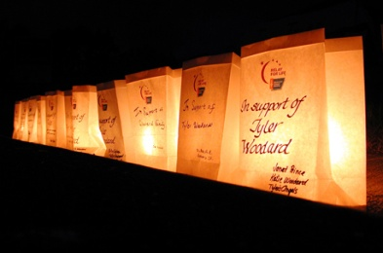

Relay For Life represents the HOPE that those lost to cancer will never be forgotten, that those who face cancer will be supported, and that those who fight cancer will one day succeed in eliminating the disease forever. This year, we invite you to honor or remember someone who has fought or is still fighting cancer with a Luminaria (candles in paper bags). During the Lighting of the Luminaria Ceremony, candles will be lit around the track in memory and in honor of loved ones and friends who have had cancer. The ceremony will begin after dark and everyone is invited to attend.
we’re all in this fight together!
let’s find a cure

Name to be Displayed | Quantity | White Luminaria  Bags $10  (Please check one) |  | Amount
 |  | In Honor | In Memory
Total Amount |  |  |  | $

Team Name to receive credit: (optional) _____

Your Name: _________________________________________
Address: ____________________________________________
Phone: ______________________________________________
Please return this form, along with your check payable to the American Cancer Society, to:
American Cancer Society
Buncombe Luminaria
120 Executive Park, Bldg.1
Asheville, NC 28801

1.828.254.6931 www.relayforlife.org/buncombenc

