Luminaria Slideshow
As a special part of this year’s Relay for Life for Bartow and Lake Wales, we will be honoring our cancer survivors and those who have lost their battle with cancer in a slideshow. For a suggested donation of $10, the photo with the name of your loved one and a special message will be displayed in the slideshow during the Luminaria Ceremony starting at 9:15pm.
Donor’s Information
Name:_____________________________________
Phone:_____________________________________
Email:______________________________________
Loved One’s Information
Circle one: In Honor of (survivor) In Memory of
Name:_____________________________________
Message (10 words or less)
_____________________________________________________________________________

Please write In Honor or In Memory on the back of your photo and turn in at a community meeting or mail it to Bartow High School, Attn: Elizabeth Roth, 1270 South Broadway Ave. Bartow FL, 33830. Please include a self-addressed stamped envelope for its safe return. Our preferred method is emailing your photo to: relay.luminaria.pictures@gmail.com
This form is due no later than April 23, 2017
Hope to see you at Relay for Life on April 28th from 6-11pm at the
Bartow High School Stadium to help support The American Cancer Society.
There’s a name
Of the ones who are still here.
There’s a name
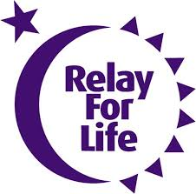
Of those gone we still hold dear,
There’s a name
Each one shining in the flames
And we know,
That every candle has a name.
~ John W. Storey

