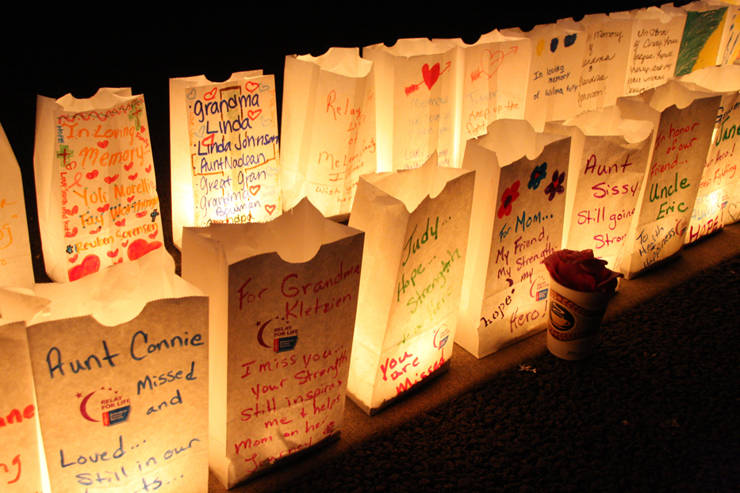

Candles Casting Light

Rekindling emotion-filled

memories of loved ones,

friends, and survivors
touched by cancer

Relay For Life offers the opportunity to remember people who have lost their lives to cancer and honor those who have won their battle by brightening the night with the glow of illuminated bags called Luminaria. All represent someone special who has been profoundly affected by cancer, and the family and friends who continue to fight back in their honor.

This year, you may choose two different Luminaria to light the night at Relay For Life of Richmond/Henrico

White Luminaria Bag - $10 to remember / honor those affected by cancer

Gold Luminaria Bag - $25 to remember / honor those affected by cancer

Please light the night in memory of or in honor of my loved one who has been touched by cancer. I understand all proceeds will benefit the American Cancer Society.

Please print

Donor’s Name____________________________________________________________

Address_________________________________________________________________

City, State, Zip___________________________________________________________

Phone (__________)__________________Email:___________________________________________

Luminary #1: In Honor of In Memory of

Name as you want it to appear on the bag: ___________________________________________

Type of Tribute: $25 Gold Bag $10 White Bag

Luminary #2: In Honor of In Memory of

Name as you want it to appear on the bag: ___________________________________________

Type of Tribute: $25 Gold Bag $10 White Bag

Total Donated: $_______________ Please make checks payable to the American Cancer Society

Please indicate for credit:

Team Name: __________________________________________________________________

Individual Team Member’s Name __________________________________________________
Please return completed form with your payment to a Relay For Life team member or mail to:
Attn: Relay For Life of RIC/Henrico
American Cancer Society
4240 Park Place Court
Glen Allen, VA 23060

The American Cancer Society cares about your privacy and protects how we use your information. To view our full privacy policy or if you have any questions, please call the Society at 1-800-227-2345 or visit us online at cancer.org and click on the "privacy" link at the bottom of the page.

