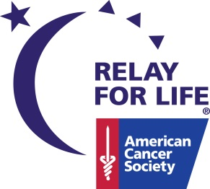
American Cancer Society
Relay For Life

Luminaria Order Form

Relay For Life, a celebration of life, is coming soon to your local community. Part of every Relay For Life is the Luminaria Ceremony to remember those who have been effected by cancer. During this ceremony, luminaria (candles in white paper bags) will line the inside of the walking track. The luminaria will be lit in honor of cancer survivors and those who have lost their lives to cancer. The Lighting Ceremony will begin around dusk and the community is invited to attend. To find your local event please visit relayforlife.org.
We want to give everyone an opportunity to pay tribute to their loved ones and friends and help fight the disease that claims so many lives. You do not need to be an actual participant in the celebration to take part in this tribute. With your donation, the names of individuals you designate will be printed on luminaria bags.
If you would like to participate in our candle lighting and provide support for the research, education, advocacy and services of the American Cancer Society, send in the form below. The more we fight this disease, the more lives we save.

For more information on luminaria or Relay For Life, contact your American Cancer Society at (618) 998-9898, option 3.

Please light a candle in honor of my loved one and/or friend who has survived or lost their life to cancer. I understand the proceeds go to the American Cancer Society.

YOUR NAME: ________________________________________________________________

YOUR RELAY COUNTY: _______________________________________________________

ADDRESS: ___________________________________________________________________

PHONE #/EMAIL:______________________________________________________________

LUMINARIA NAME: ___________________________________________________________

LUMINARIA NAME:____________________________________________________________

LUMINARIA NAME:____________________________________________________________

LUMINARIA NAME:____________________________________________________________

$10.00 via cash or check made out to the American Cancer Society can be turned in at the event or send to:
American Cancer Society
4503 W DeYoung Suite 200C
Marion, IL 62959

All cancer survivors are invited to participate by walking in the first lap of the
Relay For Life called the Survivor’s Lap. No charge involved.

