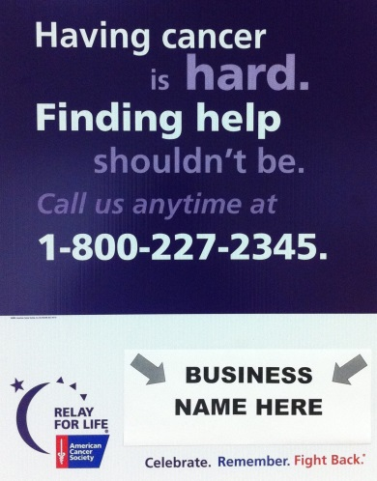

CANCER FACT SIGN FORM

Relay For Life of Washington Parish

Saturday, October 21, 2017 at Zemurray Park

$100 Cancer Fact Sign Sponsor

**Deadline: October 2, 2017**



Make Checks Payable to:

American Cancer Society

Relay For Life of Washington Parish

2605 River Road | New Orleans, LA 70121

Contact: Heidi Magrath at

[Heidi.Magrath@cancer.org](mailto:Heidi.Magrath@cancer.org) or (985) 966-4731

[www.RelayForLife.org/TangipahoaLA](http://www.RelayForLife.org/EastStTammanyLA)

Business name or Message as it should appear on Cancer Fact Sign:

(Please email your high definition jpg logo to Heidi.Magrath@cancer.org)

_________________________________________________________________________

Business Name: ____________________________________________________________

Contact Name: _____________________________________________________________

Phone: ______________________ E-Mail: _______________________________________

Sold By: _________________________ Team Name: ______________________________

Please make checks payable to: American Cancer Society Tax ID# 13-1788491

Amount Paid: __________ Credit Card: AMEX ___ Visa ____ MC ___

Name on Card: ____________________________________________________________

Card Number: _________________________________ Expiration: _________________

Address: _________________________________________________________________

City: ____________________ State: ______________ Zip Code: ___________________

Signature: ________________________________________________________________