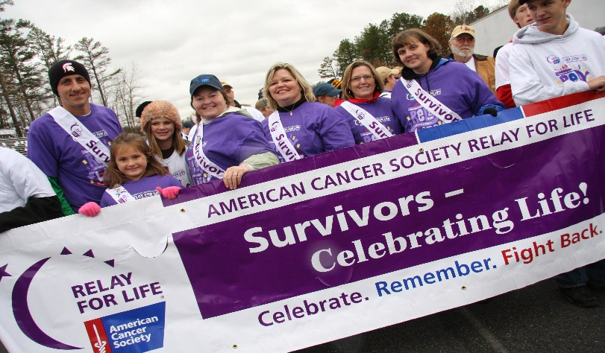

**SURVIVORS**

*** FOOD *** PRIZES *** ENTERTAINMENT***

Get your portrait taken, make your “Wish Upon a Cure” to add to the HOPE chain, make your own birthday decoration to add to the HOPE wall, and pick up your chance ticket to win a prize each hour throughout the Relay! Entertainment, dinner and lots of fun for each of our very special SURVIVORS!

Entertainment and Activities

…Minute to Win It…Donut Eating Contest…Rock Wall…

*Theme Laps: Under the Sea, Minions, Lion King, Ducktales, Lilo & Stitch, Tutu, Pirates, Monsters, Princess (High Heels), Decades, Superheroes, Sports, Villains, and Bedhead*

Please see the attached list for even more FABULOUS Relay fun!

“Wish Upon a Cure”

Friday, April 17, at 6 PM

Until

Saturday, April 18, at 10 AM

Visit [www.relayforlife.org/naplesfl](http://www.relayforlife.org/naplesfl)

Relay For Life of Naples

Website:

[www.relayforlife.org/naplesfl](http://www.relayforlife.org/naplesfl)

Facebook:

<https://www.facebook.com/rflnaples>

Twitter:

<https://twitter.com/relaynaples>

Bark For Life Website

[www.relayforlife.org/barknaplesfl](http://www.relayforlife.org/barknaplesfl)

We save lives and create more birthdays by helping you stay well, helping you get well, by finding cures, and by fighting back.

cancer.org | 1.800.227.2345

#### UPCOMING EVENTS

|  |
| --- |
|  |
|  |
| Tacos and Tequila & Aldo’s restaurants are holding fundraisers THIS week! Stop in and help out your fellow Relayers! |
|  |
|  |