Relay For Life of Leeward O`ahu
Saturday, April 15, 2017
10 AM – 10 PM
Kapolei High School Plaza

Please share this information with your team members and guests.

Relay Theme
- “RELAY around the world”

Important Dates and Deadlines
- All REGISTERED participants who have raised $100 or more by March 10th will receive an event t-shirt. We will NOT be giving out t-shirts post event.
- Team Captain Meetings
Location: Kapolei High School Cafeteria (unless noted otherwise)
Time: 6:00 p.m.
  - February 1, 2017
  - March 1, 2017 (Kapolei High School- Bldg. H, bottom floor)
  - March 29, 2017: Campsite Selection
  - April 12, 2017: T-Shirt Distribution Night / Final Team Captain’s Meeting

School Rules
- No pets allowed
- Clean-up after yourselves
- No open flames allowed (i.e., hibachi or butane); propane sternos are allowed to keep food hot.
- If bringing a generator, please make sure it is as quiet and smoke-free as possible as we don’t want to disrupt your neighboring campsites.
- NO DUMPING OF OIL OR FOOD ON SCHOOL PROPERTY!!!

Please follow these standards and rules so that we can continue being permitted to hold this event at this school. One violation can affect the entire event. Mahalo.

Relay For Life Standards
- No alcohol or tobacco allowed.
Team / Campsite Set-up
- Driving will NOT be allowed on the Plaza for the safety of our Relayers; however, volunteers and golf carts will be available to help deliver team items to campsite location at the unloading zone. Please mark team name & campsite # on top of each item. Once you have unloaded your vehicles, please move them to the designated parking areas. Do not leave your car unattended in the unloading area.
- You are free to pitch a canopy/tent within your 20’x20’ or 10’x10’ campsite. Because of the school’s sprinkler system, there will be NO TENT STAKES/SPIKES allowed on the grass. Please use buckets of sand, dumbbell-type weights, and/or water buckets to weigh down your tent as it could get windy on-site.

Food: Please be mindful of any food being SOLD. If you are selling food that day/night, you will to have a “Temporary Food Establishment Permit”. Applications are available thru our Event Leadership Team. Applications need to be turned in to Robyn Canlas by the 3/29/17 meeting.

Participant Parking: Please refer to Attachment A (Parking Map) for distribution to your team members. Parking in unauthorized areas may result in the towing or citation of your vehicle and will be the responsibility of the participant. One (1) reserved parking pass will be given to each of the top 20 teams as of April 12, 2017. Passes will be distributed at the 4/12/17 meeting. After 10:30 PM, participants may find available parking in the Reserved parking lots.

Registration & Finance
- Registration opens at 9:00 A.M.
  - Pick-up Team Mission and Event Bag
  - Pick-up earned T-shirts (1 shirt for every $100 collected in team donations on team average) that weren’t picked up at the last Team Captain Meeting.
- Finance opens at 9:00 A.M.
- All remaining donations will need to be dropped off at:
American Cancer Society
Attn: RFL of Leeward O`ahu
2370 Nuuanu Ave
Honolulu, HI 96817

External Communication
- Help us share the joy of Relay by posting pictures and comments on:
  - Facebook - Like us at "Relay For Life of Leeward O`ahu "
  - Twitter - Connect to us at "RFLLeewardOahu"
  - Instagram – Follow us at "RFLLeewardOahu"

On-site Fundraisers (more team fundraisers will be listed on a separate sheet)
- Luminaria
  - Candle lit bags are a minimum $10 donation for the WHITE bags, $15 for the PURPLE bags, and $20 for the GOLD bags.They will be sold on-site at the Luminaria tent which will be located in the Registration tent. For those teams that pre-sold and pre-decorated luminaria bags, please pick-up your sand and battery-operated candles from the Luminaria tent. Please return all unsold bags. We’ll be asking all teams to start placing their candles around the track from 7:30 PM.

- If your team is hosting an on-site fundraiser, please let our Team Development Chairs know by the Wednesday, April 12 Team Captain meeting, so we can include your fundraiser in our Event Program.

Team Takedown and Clean-Up: We encourage you to stay for the entire event. Your cooperation and courtesy is requested to wait until AFTER the CLOSING CEREMONY before breaking down your tent site. Each site is responsible for removing its own trash. Please take bagged trash to the dumpster.

Again, for the safety of our participants, vehicles are not permitted on the Plaza. However, volunteer-driven event golf carts will be available to take your equipment, tents, and so forth back to the loading/offloading area fronting the parking lot area. Please notify a committee member in the TURQUOISE “EVENT LEADERSHIP TEAM” shirts of your need.

Here are some suggestions as to what you should bring to make your stay at Relay For Life a lot more pleasant!

- TEAM SPIRIT
- Canopy or tent
- Ground cover (i.e., tarp or moving quilt)
- Competitions / Activities
- Lanterns/flashlights
- Lawn chairs
- Table(s)
- Snacks and beverages
- Water
- Cooler (ice chest)
- Sunscreen
- Camera
- Warm clothing, rain gear
- Board games
- Insect repellant
- Trash bags
- Toiletries
- Comfortable shoes
- Blankets, cots, sleeping bags
- Money for food and other activities (On-site fundraisers section to come)
- Clipboard to post activities list
- Cell phones to keep track of team members & coordinate cars
- Your team’s on-site activity and/or fundraiser

Attachment A
Parking Map
School
Entrance
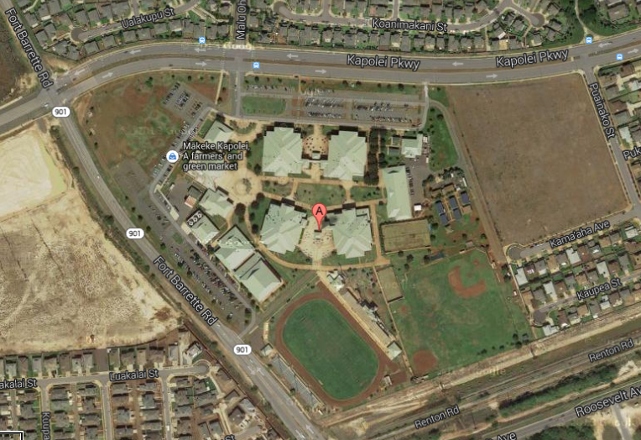
Committee / VIP Parking
2
5
4
3
1

