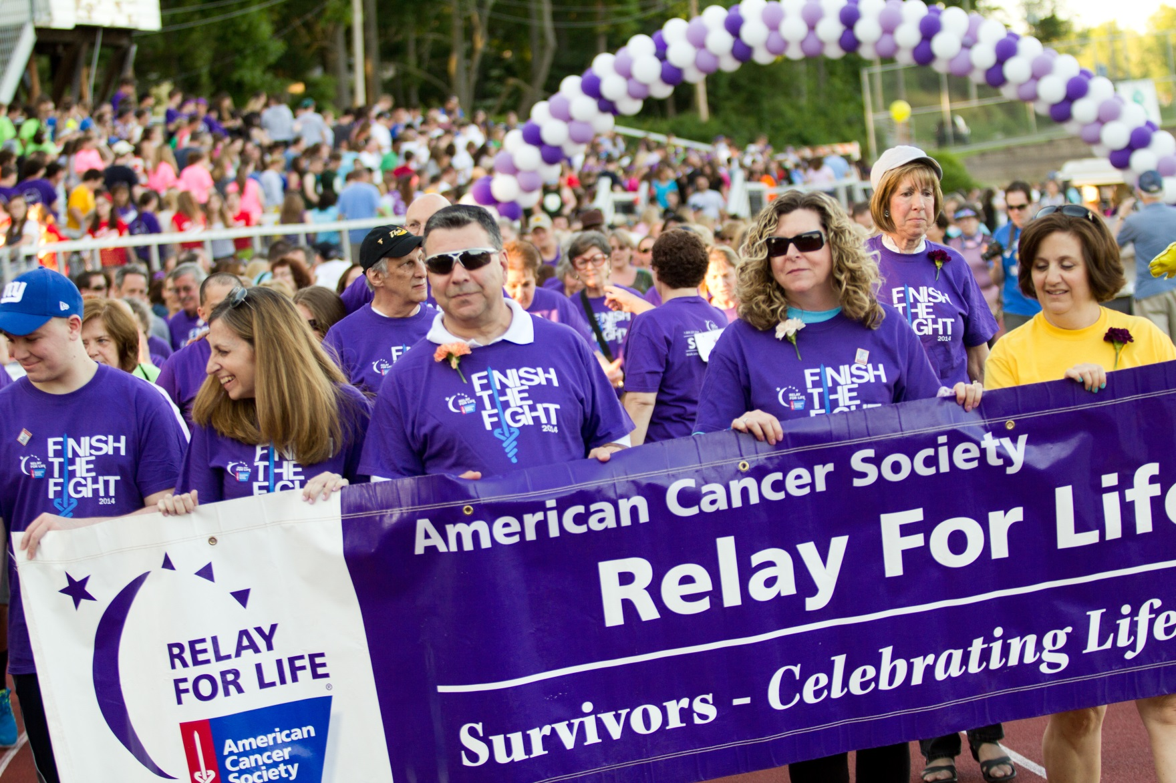
Annual Survivor Lap
RELAY FOR LIFE OF FAYETTE COUNTY
HONORING OUR SURVIVORS

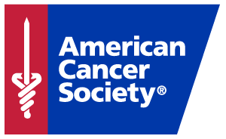
Our Survivors are the reason we Relay, and our Annual Survivor Lap will officially kick off our 2017 Relay For Life of Fayette County, GA event! Bearing survivor shirts and medals, we hope to have over 300 survivors represented on our track at the event!

Please give this form to your Team Captain or mail to:
American Cancer Society
c/o Calle Wallace
250 Williams St., PO Box 56566
Atlanta, GA 30303
Whether you were diagnosed 25 years ago, or 25 days ago, you are the reason we Relay. Register today as a survivor with the Relay For Life of Fayette County, GA so you can be honored and celebrated at our event. Survivors registered by April 1st, 2017 will be guaranteed a commemorative survivor shirt and medal.
*All survivors who register after April 1st will be given a shirt and medal as supplies last*

Did you know that you are a cancer survivor from the moment you are diagnosed?
More people than ever are surviving cancer and thriving after treatment; these people are your friends, family, neighbors, teachers, and loved ones in Fayette County, and we want to honor and recognize them at our Relay For Life event. Are you or someone you know a survivor?
REGISTER TODAY!

Relay For Life of Fayette County, GA Survivor Lap

Team Name:
Your Name:
Address:
City:
Email:
Phone Number:
My T-Shirt Size Is: S M L XL XXL 3XL 4XL
Type of Cancer:
Year of Diagnosis:
Registration Opportunities:
□ Join an Existing Team – Team Name:
□ Survivor Lap Only
□ Participant Only
Golf carts will be provided for those who need assistance. Please indicate if you will need a golf cart to escort
you from the parking lot to/around the track.
□ Yes, I will need assistance
As a participant in Relay For Life® I, for myself, my executor, administrators, heirs, devises and assigns do hereby discharge the American Cancer Society, the event site, their management, their officers, board members, employees, members, sponsors, volunteers, organizers or their representatives, or their successors and all cooperating businesses and organizations from all claims of damages, demands, actions and causes whatsoever in any matter arising from or growing out of my participation or that of my child in the event. The American Cancer Society provides Relay For Life® participant ("Relay participant") Web pages as a service. All donations received through the Relay participant pages are contributions for which no goods and services have been provided. Therefore, Relay participant pages shall not contain any language, which suggests that merchandise will be provided in exchange for their contribution. Relay participants are expressly prohibited from offering merchandise sales, prizes, raffles, giveaways, lotteries, contests, tournaments, lucky draws, or any games of chance on their Relay participant pages either as an outright token action or as an inducement to solicit donations. As a Relay participant, you are limited to disseminating information that is for the benefit of the American Cancer Society's Relay For Life®. The Relay participant pages are expected to represent the American Cancer Society in a professional manner in accordance with the Society’s Web policy. Furthermore, Relay participants are expressly prohibited from including information on their Relay For Life® Web pages that are inconsistent with the American Cancer Society's mission and values. Relay For Life® Web pages shall not advertise for-profit business. Examples of prohibited subjects include, but not are limited to, the sale or promotion of any goods or services, an endorsement or perceived endorsement of any goods or services, support or opposition of a political party or a political candidate, materials affiliated with tobacco or tobacco-related products and any other products inconsistent with the Society mission, content of any nature which may result in fraud or misrepresentation to the public, pornographic or otherwise offensive sexual materials, racially or ethnically prejudicial materials, overtly religious materials or any other information that may be offensive to the general public. Relay participant agrees to indemnify the American Cancer Society for all fines, fees and expenses incurred as a result of the breach of any contractual obligations of the Relay Participant. I give my full permission for the use of my name and photograph in this event. I also give my full permission for such first aid as deemed necessary to be provided to me or my child on the premises or prior to transport to a hospital for further treatment. If I am under the age of 18, my parents have consented to my participation at the American Cancer Society’s Relay For Life®. When I am on the premises of the American Cancer Society or at an American Cancer Society sponsored event, my parents have given their consent for me to participate in Relay For Life® and have agreed to all of the Relay Participant Donation and Solicitation Agreement Terms and Conditions on my behalf. Content Disclaimer The American Cancer Society does not exercise any editorial control over the information you may find on Relay participant Web pages. Opinions expressed on Relay participant Web pages do not necessarily represent the official views of the American Cancer Society.

Signature: ____________________________________________________________ Date: ____________________
(Parent Signature if participant is under 18)

