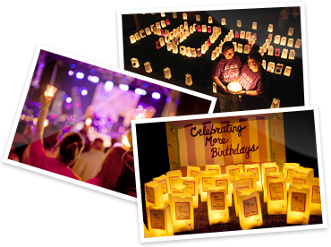

American Cancer Society
Relay For Life of
Solvay Geddes Westvale 2017
Luminaria Order Form

When the sun goes down at every American Cancer Society Relay For Life event, hope shines the brightest. During the Luminaria Ceremony, hundreds of luminaria light the track or path to celebrate the lives of those who have battled cancer, remember loved ones lost, and fight back against a disease that has taken too much. This ceremony of light symbolizes the hope and perseverance with which we all continue to fight.

You can give to the American Cancer Society and keep the flame of hope lit by dedicating a luminaria in memory of someone lost to cancer or in honor of someone still fighting or who has beaten the disease.

The suggested luminaria donation amount is $10 each. Please send your tax-deductible donation, payable to the American Cancer Society, and the bottom portion of this form to:
American Cancer Society, Attn: RFL of Solvay Geddes Westvale, 6725 Lyons Street, East Syracuse NY 13057
In □ Memory □ Honor
of_____________________________________________
Message (10 words maximum) ______________________________________________
In □ Memory □ Honor
of_____________________________________________
Message (10 words maximum) ______________________________________________
In □ Memory □ Honor
of_____________________________________________
Message (10 words maximum) ______________________________________________
In □ Memory □ Honor
of_____________________________________________
Message (10 words maximum) ______________________________________________
In □ Memory □ Honor
of_____________________________________________
Message (10 words maximum) ______________________________________________
In □ Memory □ Honor
of_____________________________________________
Message (10 words maximum) ______________________________________________
In □ Memory □ Honor
of_____________________________________________
Message (10 words maximum) ______________________________________________
In □ Memory □ Honor
of_____________________________________________
Message (10 words maximum) ______________________________________________
Total amount enclosed: $__________ (suggested donation of $10 per luminaria)
Credit donation to: □ Participant □ Team ____________________________________________________________

