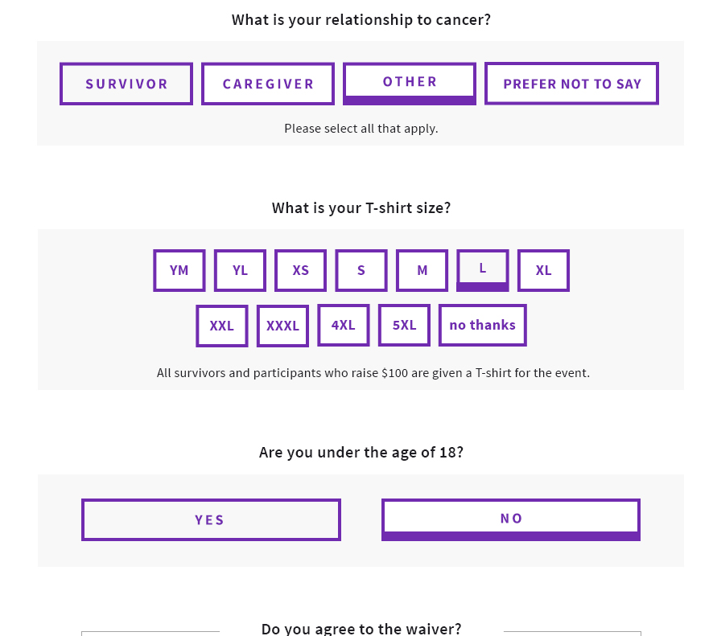

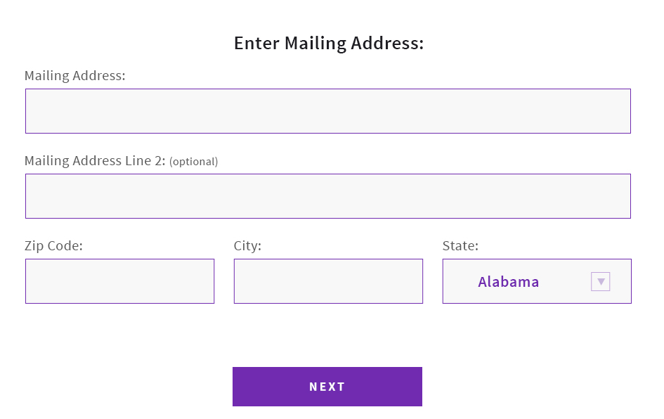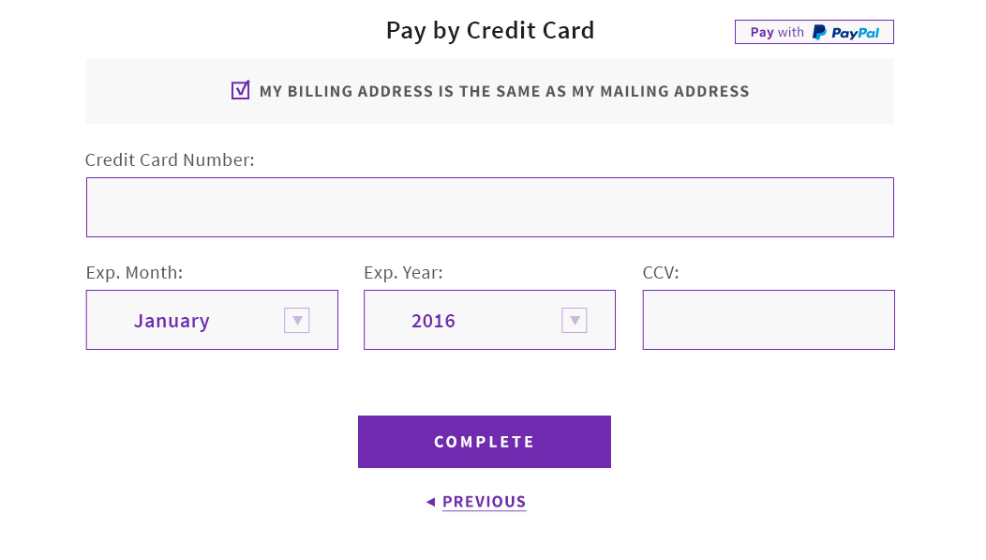
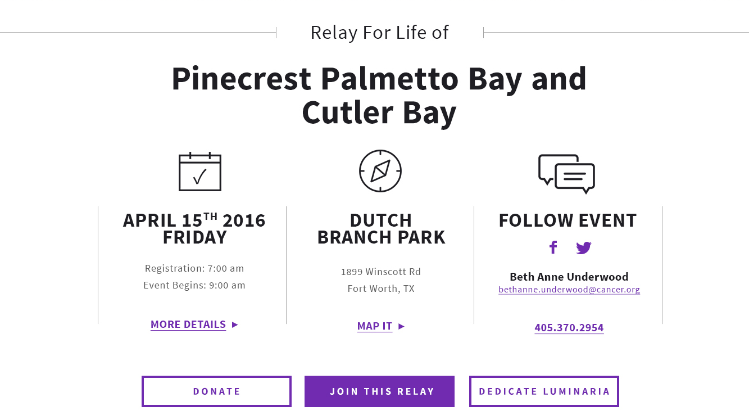
You must create or log into your Society Account to begin the registration process.
- If you are a NEW participant, you will Create an Account.
- If you are a RETURNING participant, you will log in.
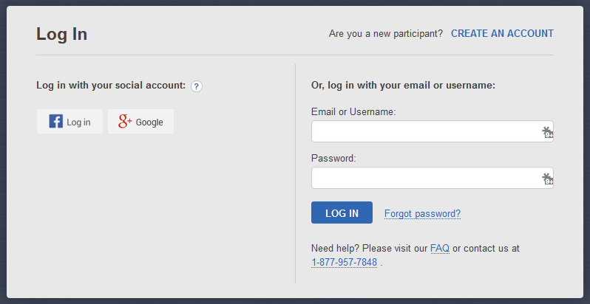

Step 2: Society Account
Step 1: Join This Relay
Visit your local Relay web site and click Join This Relay button to begin registration. OR call 1-800-227-2345 for additional registration options.
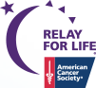

---------------------------------------------------------------------| Join a Relay|--------------------------------------------------------------------
Step 4: Complete Registration.

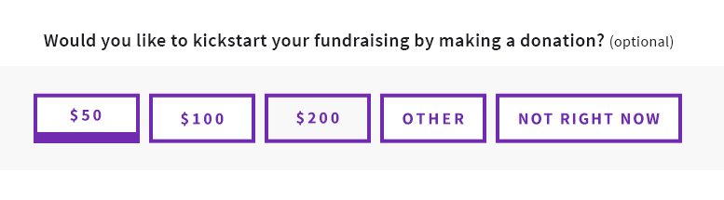

If you have any questions or concerns, please contact your local staff partner or call the American Cancer Society at 1.800.227.2345.
Step 3: Choose How You Will Participate.
