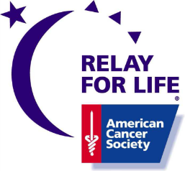
ATTENTION

CANCER SURVIVORS

The Cabarrus County-Concord Relay For Life and The American Cancer Society would like to invite you for a celebration of Cancer Survivorship.
Please join us for dinner and a special ceremony at
Cabarrus County’s Relay for Life 2015
by walking the survivor lap with other cancer survivors.

Cabarrus Arena & Events Center
4551 Old Airport Rd., Concord, NC 28025
May 2nd 2015, 11 AM - midnight

Opening Ceremony 11:00pm
Registration 11:00 a.m.-until
Dinner 5:00 p.m.-6:30pm
Survivor Walk 7:00 p.m.
- - - - - - - - - - - - - - - - - - - - - - - - - - - - - - - - - - -
REGISTRATION FORM
All Cancer Survivors will receive a free t-shirt with completed registration.

Name____________________________________Address____________________________________________
City:_____________________ State:_______ Zip:____________ Phone: _____________________
Email address________________________________________________________

T-Shirt Size (please circle): S M L XL XXL 3XL

Type of Cancer ______________Years of Survivorship ______________

Survivors are welcome to bring a guest for $6.00 each to the survivor dinner. Will you be bringing a guest? Yes ___ No ___ Number_________

Please mail the bottom of this form and any guest dinner fees to:

RFL Survivor
PO Box 1108
Kannapolis NC 28081

Make checks payable to American Cancer Society
Questions call Kim 704-467-2732 or Shelby 704-886-7361 or email rflcabarrus@gmail.com
Deadline for registration is April 18th 2015

