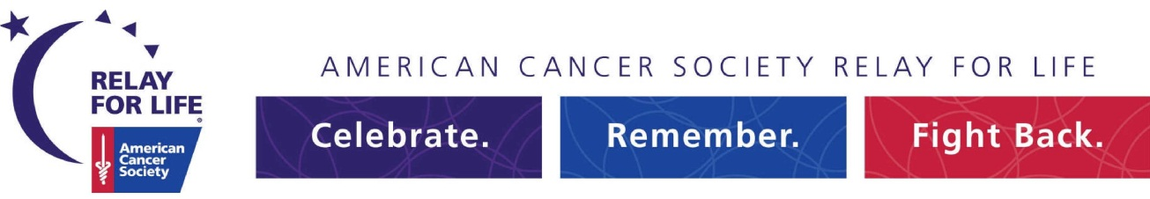

Relay For Life of Bay Ridge, Bensonhurst, & Dyker Heights
June 20th, 2015

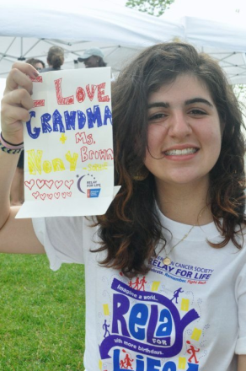

As the sun sets and darkness falls, the night is brightened by the glow of illuminated bags called Luminaria, each bearing the name of someone who has battled cancer. Some bags celebrate cancer survivors, while others help us honor and remember those gone too soon. All represent someone special who has been profoundly affected by cancer, and the family and friends who continue to fight back in their honor.
Would you like to celebrate or remember someone during the Relay For Life Luminaria Ceremony?
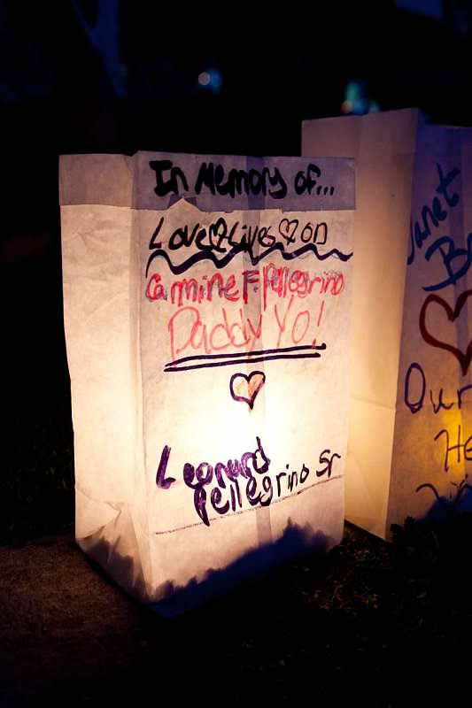
For a donation of $5, your Luminaria bag will be included in the evening’s ceremony. You have the choice to decorate it yourself or to have it decorated for you.
Please join us in walking the track to celebrate and remember all of our loved ones touched by cancer.
For more information please staff partner Brandon Westbrook at Brandon.Westbrook@cancer.org

Luminaria Order Form – RFL of Bay Ridge, Bensonhurst, & Dyker Heights

My gift is in honor of:_______________________________________________________________
- or -
My gift is in memory of: _________________________________________________________________

Total donation for candles ($5 per candle): ___________________

Your Name: ________________________________________ Phone: ____________________________

Address: _____________________________ ________ City: _____________ St: _____ Zip: ________

Email: _______________________________________________

This donation will be credited to: _____________________________________
(please fill in team name or participant name)

