Cancer Has a Face
Each year at Relay For Life of Reston, we celebrate survivors and remember loved ones in this special slide show presented in conjunction with the Luminaria Ceremony. If you would like a special face you know to be featured in the presentation, please return this form.

ALL PHOTOS MUST BE SUBMITTED BY MAY 9, 2015.

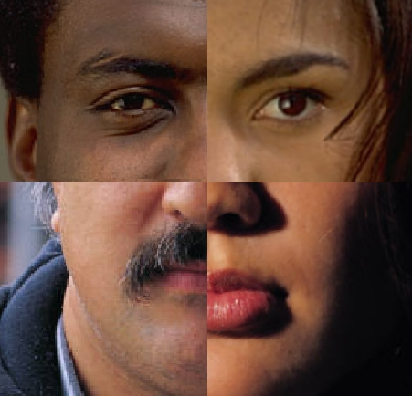

IMPORTANT: Even if you have submitted a picture in a prior years, please re-submit your picture this year. All photos will be confirmed via email. You will receive a confirmation within 48 hours via email, after your picture has been received. If you do not hear back from us within one week of sending your picture, please follow-up with an email to ensure your picture has been included.

Email Submission

Send an email to: restonrelay@gmail.com. Please label the subject of the email: Cancer Has A Face, and include the information requested below in the body of the message. Please send only one photo per email; pictures must be in .jpg format, and should be no larger than 512KB.

Photo Submission Required Information

Step 1. Complete your contact information:

Your Name:
Team name:
Team captain:
Cell phone: |  | Email:

Step 2. Tell us about your Honoree:

Honoree’s Name:
Honoree is a (please identify): |  | Proud Survivor____ | Lost Loved One____

