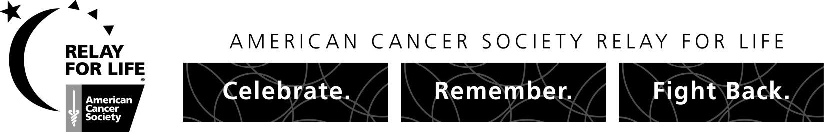

LUMINARIA FORM
Light a Luminaria at the
American Cancer Society Relay For Life
Participant Name:
___________________________________

Team Name: _________________________
Remember or Honor a Loved One Touched by Cancer

Merced Relay For Life
April 29th – Merced College

It’s one of the most inspirational moments at the American Cancer Society Relay For Life. It takes place after dusk during Relay For Life. The Luminaria Ceremony offers everyone at Relay the opportunity to pay tribute to those whose lives have been touched by cancer. It is an opportunity to help in the fight against cancer with a donation and to honor someone in your life who has faced the disease. What is a Luminaria? A Luminaria is simply a bag filled with a glowing light. Each Luminaria bears the name of a person who has battled cancer. The bags begin to glow right before the Luminaria Ceremony. As they glow into the night, they light the way for the walkers…a path of hope. Please fill out the form below to order a Luminaria for each friend or loved one who has struggled with cancer. You can salute a cancer survivor by placing their name under “in honor of”; or you can remember someone who has lost their battle by placing their name under “in memory of.” Your contribution will make a difference and will help save lives. Thank you.

Please light a Luminaria in honor or in memory of my loved one who has had cancer. I understand proceeds will benefit the American Cancer Society in the fight against cancer.

Please mark one:
I will be making my bags |  | Please make my bags for me

P L E A S E P R I N T C L E A R L Y
QTY. | IN HONOR OF | QTY. | IN MEMORY OF

SUGGESTED DONATION IS $10.00 PER LUMINARIA LINE

TOTAL AMOUNT ENCLOSED: $_______________________________ NUMBER OF LUMINARIAS: ______________________

Donor: ____________________________________________________ Phone: ________________________________________

CHECK (s) enclosed, payable to American Cancer Society MasterCard Visa American Express Discover

CASH
Card No. ___________________________________________
Send Contribution Form with Donation to:

AMERICAN CANCER SOCIETY – RFL Merced
1101 Sylvan Ave, Suite C-105, Modesto, CA 95350
FAX: (209) 524-7454

OR – GIVE TO YOUR FAVORITE TEAM MEMBER

Expiration Date: _________________
Address: ___________________________________________

City, State, Zip: ______________________________________

Signature___________________________________________

There is no finish line until we find a cure!

